**Group 1**

Project C#

Guess The Word

* Open Server and Client
* Choose the category and difficulty from the server.
* Click Start in Server Form.
* Click Play in Client Form
* Then Play The Game

**Note:**

*In client code please replace the IP with your server IP to start playing in your device)

*Please Attach the Database(2016) with connected method in: **Start Server_Form**.

*Kindly Change path of text file as well in the method : **check_winner().**

*You can play the game on different devices on the same network.

**The team**

1. Ali Sayed Ali
2. Verina Wasfy
3. Amira Yousry
4. Ahmed Abdallah
5. 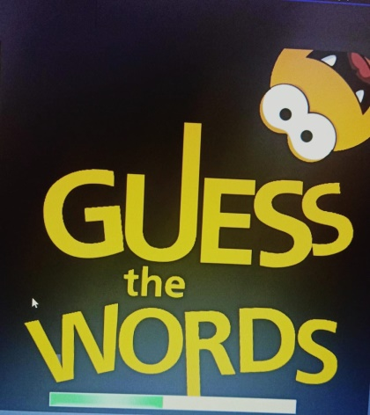Doha Talaat